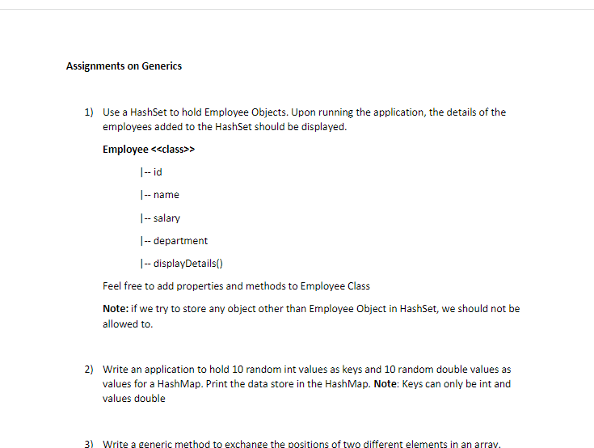

1.

package generics;

import java.util.HashSet;

import java.util.Set;

class Employees {

private long id;

private String name;

public Integer salary;

public String department;

public Employees(long id, String name,int salary,String department) {

this.id = id;

this.name = name;

this.salary = salary;

this.department =department;

}

@Override

public String toString() {

return "Employee [id=" + id + ", name=" + name + ", salary=" + salary + ", department=" + department + "]";

}

}

public class Employee {

public static void main(String[] args) {

Set<Employees> customers = new HashSet<>();

customers.add(new Employees(101, "Rajeev",20000,"dep1"));

customers.add(new Employees(102, "Sachin",25000,"dep2"));

customers.add(new Employees(103, "Chris",30000,"dep3"));

customers.add(new Employees(101, "Rajeev",20000,"dep1"));

System.out.println(customers);

}

}

2.

1. **import** java.util.HashMap;

**import** java.util.HashSet;

**import** java.util.Map;

**import** java.util.Scanner;

**public** **class** hello {

**public** **static** **void** main(String[] args)

{

Map<Integer, Double> s = **new** HashMap<Integer, Double>();

s.put(10,20.12);

s.put(11,21.73);

s.put(12,22.20);

s.put(13,23.10);

s.put(14,24.64);

s.put(15,25.17);

s.put(16,26.48);

s.put(17,27.39);

s.put(18,28.90);

s.put(19,29.55);

**for**(Map.Entry m:s.entrySet()){

System.***out***.println("int values: "+m.getKey()+" "+"double values: "+m.getValue());

}

}

}

3.

**package** generics;

**public** **class** ExchangeThePositionOfElements {

**public** **static** **void** main(String[] args) {

Integer [] iList = {1, 5, 4, 10};

*swap* (iList, 1, 2);

**for** (Integer i: iList)

System.***out***.print (i +", ");

}

**public** **static** **void** swap(Object[] a, **int** i, **int** j){

Object temp=a[i];

a[i]=a[j];

a[j]=temp;

}

}